Focused Note-Taking Overview

Taking notes and never looking at them again is obviously not useful. Yet, simply reading your notes is not a sufficient study strategy. You must interact with them multiple times to improve retention and understanding! Here is an overview.

Phase: | Goals
1.  Take Notes | - Choose a format (Cornell Stye, 2 or 3 Column Notes, Consumable, Graphic Organizer, Interactive Notebook, Mind Maps, etc)  - TOP: Date, Title, Essential Question, Learning Objectives  - RIGHT: Record main ideas, phrases, important information, formulas, definitions, and examples. Sufficient space between main ideas (for later interaction).  - LEFT: Questions, diagrams, keywords, main ideas  - Paraphrase what you hear in your own words  - Organize notes using indentation, bullets, outlines, skipping lines, color coding
2.  Process Notes | - Revise your notes by adding or deleting information  - Exchange ideas by collaborating  - Chunk notes by numbering each new concept or “big idea”  - Circle key words and vocabulary  - Highlight main ideas (recommend a color scheme for added purpose)  - Use a ? to identify points of confusion, then clarify by asking another student or the teacher  - Use a * to identify information likely to appear on a quiz or test
3.  Connect Thinking | - Write a (higher-level) study question about the main idea in each chunk (Bloom’s Levels 3-6, Costa’s Levels 2-3)  - Write a question addressing any points of confusion or things you don’t understand  - Write a conceptual question a teacher might ask on a test  - Add original thinking to your notes by making personal connections (e.g., connecting to prior knowledge, course content, life/world)  - Use a different color pen to indicate these additions
4.  Summarize and Reflect | - Reflect on how the notes address the essential questions and learning objectives  - Summarize notes by combining main ideas, using academic vocabulary, linking answers to your study questions, and answering the essential question
5.  Apply Learning | - Save and revisit your notes as a resource or learning tool to help you apply or demonstrate what you have learned.

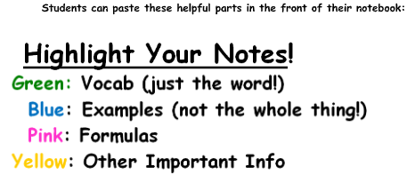

Test Review
When working through a unit review, for each question, ask yourself:
- What do I need to know and be able to do in order to answer this question? (Use a post-it note to summarize the main concept or skill needed for that question.)
- What other questions might be asked that assess the same learning objective?
- Where was this in the notes? Did we do an example like this in class? (Look over that section of the notes.)
- What questions do I still have about this problem?
- Do I need to find another similar problem to practice, or do I completely understand this one?

